Software Requirements Specification

PROJECT NAME LIBRARY MANAGEMENT SYSTEN

PROJECT MEMBERS

11508 Muzamil Khan

Table of Contents Error! Bookmark not defined.

Revision History Error! Bookmark not defined.

1. Introduction 3

1.1 Purpose 3

1.2 Document Conventions 3

1.3 Intended Audience and Reading Suggestions 3

1.4 Product Scope 3

2. Overall Description 3

2.1 Product Perspective 3

2.2 Product Functions 4

2.3 User Classes and Characteristics 4

2.4 Operating Environment 4

2.5 Design and Implementation Constraints 4

2.6 User Documentation 5

2.7 Assumptions and Dependencies 5

3. External Interface Requirements 5

3.1 User Interfaces 5

4. System Features 6

4.1 System Feature 1 6

5. Other Nonfunctonal Requirenments 6

5.1 Saftey Requirenments 6

5.2 Bussiness Rules 6

6. Other Requirenments 7

6.1 Analysis Model 7

6.2 Glossary 6

# Introduction

## Purpose

This library Management System is a system in which a Librarian can handle the data entries in a manner. Librarian can easily handle Adding, Deleting, Updating and Search data in a suitable and manageable manner.

## Document Conventions

Library Management System

## Intended Audience and Reading Suggestions

This Project is for users. This document contains the Software Requirement Specifications for this project. It covers the Interface, Use and Technical background of this project.

1. Overall Description.
2. External Interface.
3. System Features.

## Product Scope

In this world of technology and internet the most neglected area is Library. People can find many books on internet and due to bad management of the Library people miss that calm environment. People might get rid of these systems because of not having a friendly environment. They are not use to it or they are not able to understand sometimes that what they should do with this software after the installation.

This project will give library management a new experience of sorting the data in easy way. They can search anything in just one click. Adding a new thing is also very easy to use and to remove them is easy then anything. In simple words the BBMS is a new way to access the whole and huge amount of data in very manageable way for the Library.

# Overall Description

## Product Perspective

The LMS is perfectly design for the Library. There are a lot of software which are for some restaurants, banks, super stores and schools. They justify their places but for Library there is no enough quantity of software for use.

Internal Interfaces:

* User.
* Librarian.

## Product Functions

This LMS give the librarian full options such that: If they want to add new publisher or student or may be a book they can add them very easily by just filling the information that the form is asking about. As you are inserting some values so also you have an option to delete that entry at that time or after a long time.

The search button will find every single alphabet or a number whatever the user want to search in that database. The update button can update the complete information that the librarian want to update.

## User Classes and Characteristics

The user should be familiar with the following:

* How to operate a computer.
* The basic know how to use the software.

## Operating Environment

Operating Environment are as follow:

* Windows 10
* Database MySQL.

## Design and Implementation Constraints

Design and Implementation Constraints are following:

* Basic interface is used in this software.

## User Documentation

The LMS is a very user friendly software after the installation it is very basic to use. The Documentations is also available in a pdf format in case of any query user can take help from our manual.

## Assumptions and Dependencies

* Assuming that the database is not safe in the user’s computer than the data will be stored in cloud.
* The user want to save the data in other computer then the scenario will be different in some cases.

# External Interface Requirements

## User Interfaces

* Show Students:

This will show all the student details present in the database. Also gives all of the option like Add, Delete, Update and Search.

* Show Publisher:

This will also show the user all the publisher details present in the database. Also gives all of the options like Add, Delete, Update and Search.

* Show Books:

This will show all the book details. Also gives the user to Add, Delete, Update and Search options.

* Issue/Return Book:

This will set a date with the student for the record that how long the student had the book.

# System Features

The Features of LMS are as follow:

## System Feature 1

A desktop application which will be helpful to the Library to manage the data and to store the data efficiently. Sometimes the software are so complicated that the user starts to avoid them. But in this BBMS the user interface is easy to use and handle a lot of data in efficient way. Some of the major function are following which will show that the software will be easy and reliable.

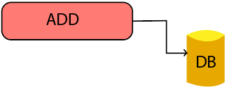

* Add Function:

This function will give the access to the user to add any new entry in the database.

* 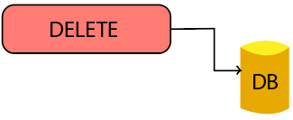Delete Function:

This will give the user to delete a complete entry from the database.

* 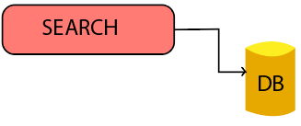Search Function:

This function will be able to search every entry which exists in the database.

* 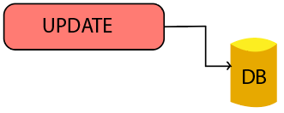Update Function:

This feature will helps the user to update the data which is entered in the database by mistake.

# Other Nonfunctional Requirements

## Safety Requirements

In this LMS all the important details and data will be stored in the database which will definitely one of the most sensitive part of the software. Once the user will understand the usage of the software then the most efficient way to store the data is to own a server which will help the user to hide the data and will also help to save the data in case the user PC is damage.

## Business Rules

As, this software is developed for the Library so only the Librarian can access all of the function on the desktop application. It is mainly developed for the ease of librarian so that the library can handle a lot of user with less time and effort.

No other user except for the librarian can access the software due to security level on the software. This software will also ask for and ID and Password of the librarian which will give the access to use the software.

# Other Requirements

Following are the requirements which are not mentioned above:

Appendix A: Analysis Models

* 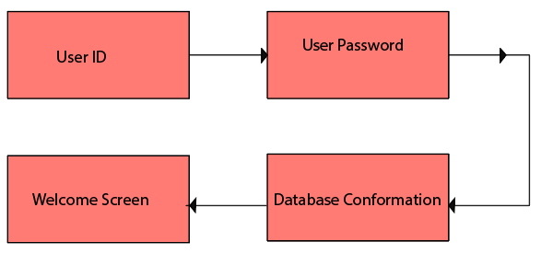Login Function :

The user will assigned with a User Id and Password. By using that User Id and Password the user will login. Database will chick that the given id and password is already exists in the database. If the user id and password is present in the database the user will see the welcome screen or selection options (show student, publisher and book).

Appendix B: Glossary

LMS: LIBRARY MANAGEMENT SYSTEM

UML DIAGRAMS

USECASE DIAGRAM

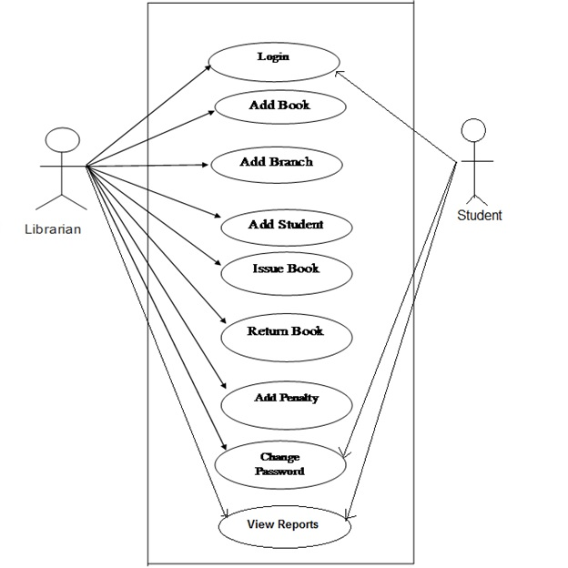

ACTIVITY DIAGRAM

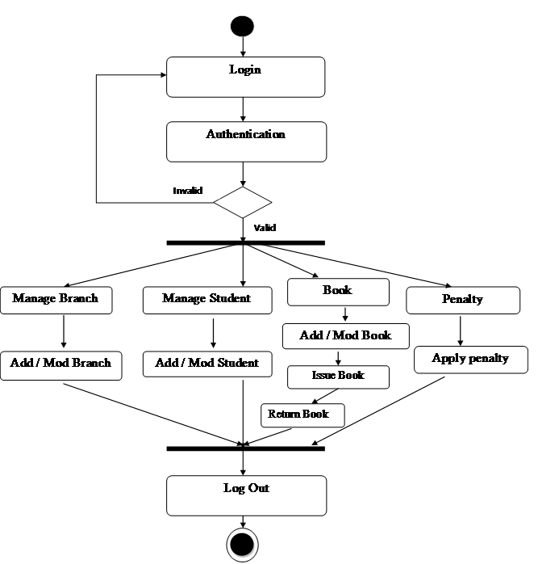

CLASS DIAGRAM

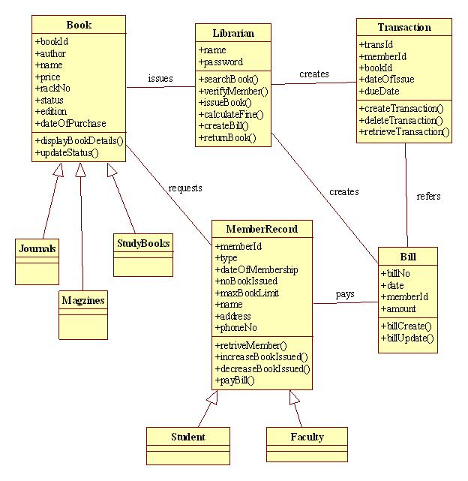

SEQUENCE DIAGRAM

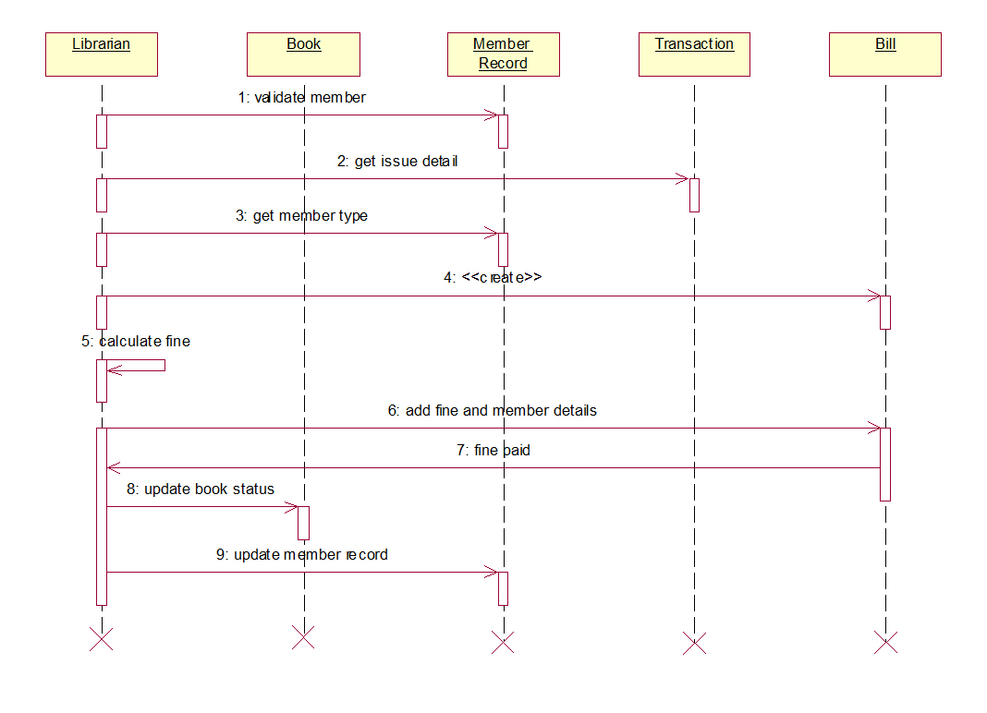

CALLOBRATION DIAGRAM

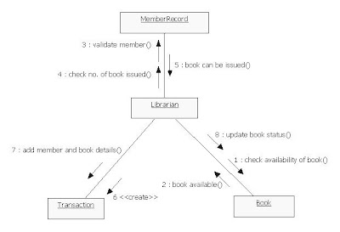  
STATE CHART DIAGRAM

